# Phase 6: User Interface Development

**Lightning App Builder**

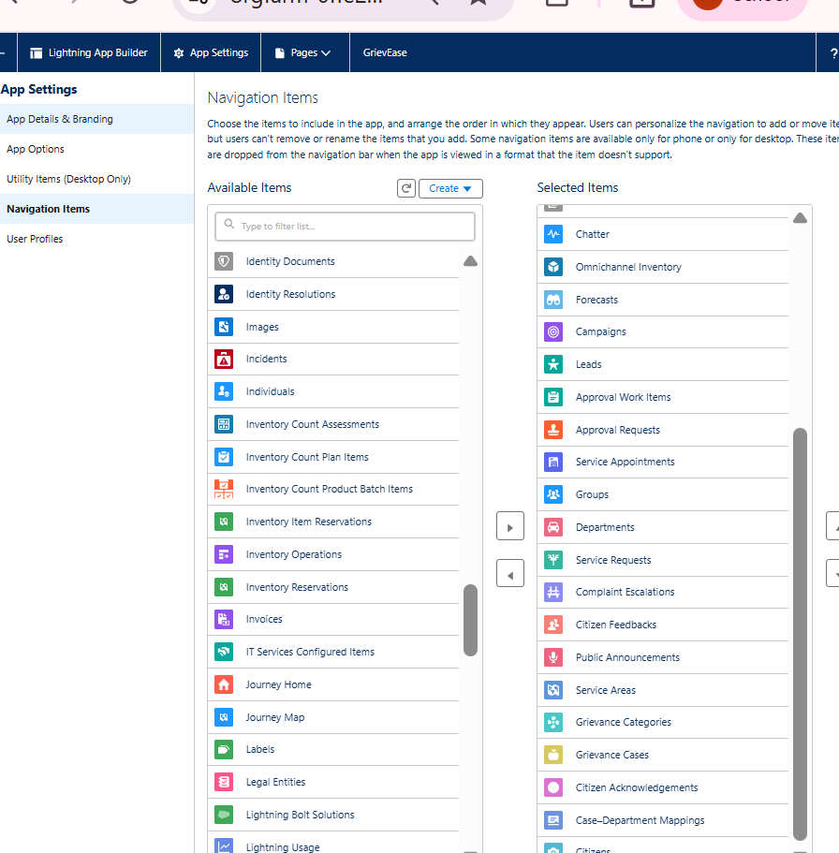

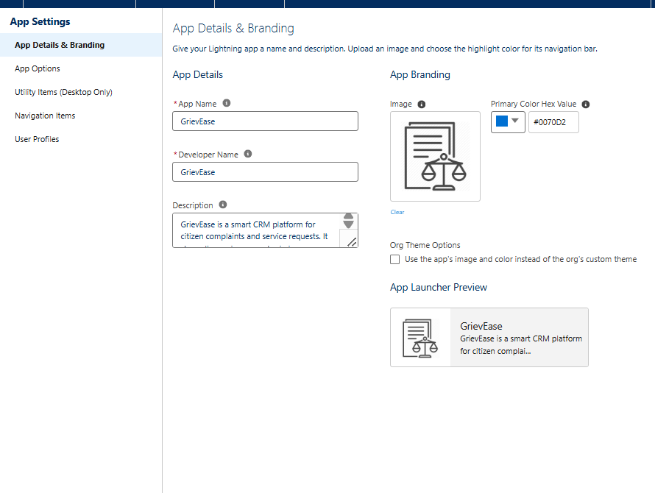

* You now have a **GrievEase CRM app** in Salesforce Lightning.
* Agents and Managers can access **all grievance records, dashboards, and reports** in one place.

**Record Page**

GrievEase Record Pages (Lightning App Builder)

Custom Grievance Case record page for better user experience

Displays all case details: Priority, Status, Complaint Type, Service Date

Shows related information:

Citizen details (Lookup to Contact)

Attachments, Comments, Case History

Related Lists show all associated records in one place

Quick Actions for common tasks:

Update Status, Escalate Case, Add Comment

Charts & Dashboards embedded for real-time analytics

Component visibility rules allow highlighting Emergency cases

Activated as Org Default or assigned per App/Profile/Record Type

If you want, I can also make a short, visual PPT slide layout with icons for Grievance Case, Citizen, Related Lists, Charts, and Actions to make it more

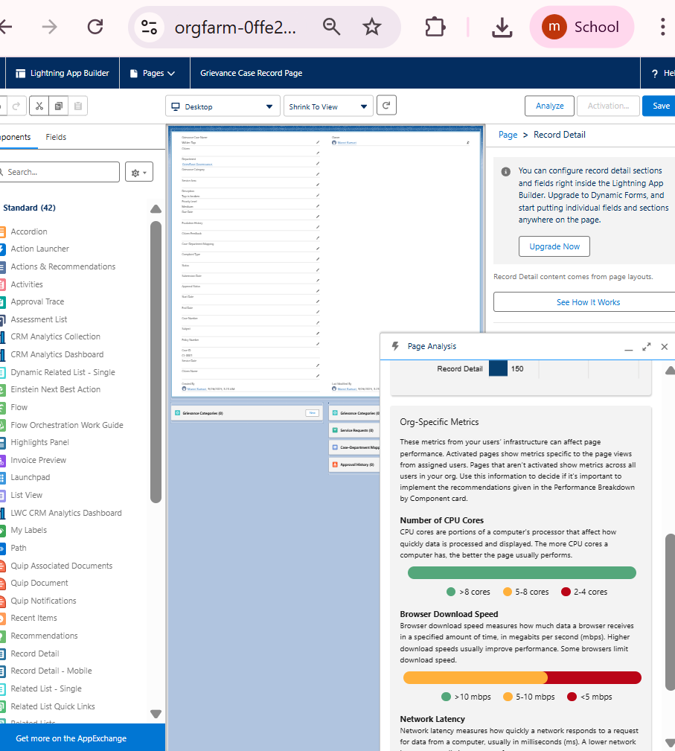

**Tabs**Added **Grievance Cases** & **Citizens** tabs for easy access

Tabs link directly to **object records**

Enhances **user navigation** in Lightning App

Supports **quick actions and reporting**

* **Home Page Layout**

**Key Components**

* **Dashboard / Report Charts:**
  + Cases by **Status** (New, In Progress, Closed)
  + Cases by **Priority** (High, Medium, Low)
  + Cases by **Complaint Type** (Normal, Emergency)
* **Recent Grievance Cases:** List of latest submitted cases
* **Quick Actions:**
  + Create New Case
  + Update Status
  + Escalate Case
* **Notifications / Alerts:** Highlight overdue or high-priority cases
* **Utility Bar**

**Steps to Add Utility Bar**

1. Go to **Setup → App Manager → GrievEase CRM → Edit**
2. Click **Utility Bar → Add**
3. Choose component type:
   * **Standard Action:** “New Grievance Case”
   * **Custom Components / Flows** (optional)
4. Set **Label, Icon, and Visibility**
5. Click **Save → Activate**

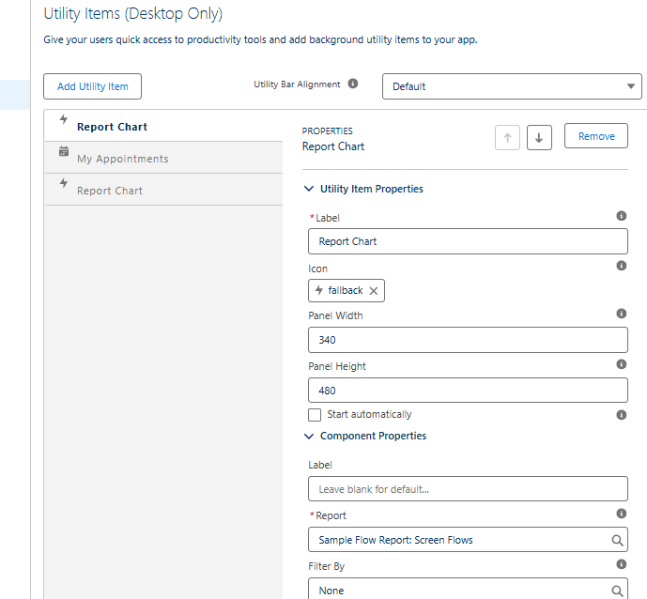

* **LWC**

**Search Grievance Cases by date** using LWC

Displays results in **interactive datatable**

Shows **key fields**: Case Number, Priority, Complaint Type, Status, Citizen

Enhances **agent efficiency** for case tracking

Can be added to **Home Page or Record Pages**